**HOME SECURITY SYSTEM USING RASPBERRY PI WITH IOT**

|  |  |  |
| --- | --- | --- |
| **INDEX** | | |
| **Chapter No.** | **TOPIC** | **Page No.** |
| **1**  1.1  1.2  1.3  1.4 | **INTRODUCTION**  **General**  Existing System  Drawbacks  Proposed System  Advantages |  |
| **2**  2.1  2.2  2.3  2.3.1  2.3.2  2.3.3  2.3.4  2.3.5  **2.4**  2.4.1  2.4.2  2.4.3  2.4.4  2.4.5  **2.5**  2.5.1  2.5.2  2.5.3  **2.6**  2.6.1  **2.7**  **2.8**  **2.9**  **2.10**  **2.11**  **2.12** | **PROJECT DESCRIPTION**  General Introduction To Embedded System  Block Diagram  Modules  Power Supply  Transformer  Rectifier  Bridge Rectifier  Voltage Regulators  **MICROCONTROLLER**  Raspberry Pi Introduction  Inception of Raspberry Pi  Hardware Layout  Description of the Components on the Pi.  Specifications  **LIQUID CRYSTAL DISPLAY(LCD)**  Introduction  Pin Diagram  List Of Commands  **IOT**  ESP8266 WIFI IOT MODULE  **BUZZER**  **CAMERA**  **IR SENSOR**  **PIEZO SENSOR**  **PIR SENSOR**  **SOUND SENSOR** |  |
| **3**  3.1  3.2  3.3 | **SOFTWARE SPECIFICATIONS**  **RASPBERRY PI SOFTWARE** Boot ProcessThe NOOBS installer Raspberry Pi Compatible Operating Systems |  |
| **4**  4.1 | **IMPLEMENTATION**  Schematic Design |  |
| **5**  5.1 | **SIMULATION AND DESIGN**  Output Screen Shots |  |
| **6** | **CONCLUSION** |  |
| **7** | **REFERENCES** |  |

**CHAPTER 1**

**INTRODUCTION**

**1 GENERAL**

Westernization of today's society has led to the increase in the number of small families while the gradual spread of living into the suburban areas has raised a significant concern in the security of the individuals. Although there are many security systems available in the market today, they are mostly expensive. The objective of the model described in this paper is to present a simple and low-cost design to make our homes smarter and safer. The Raspberry pi based framework built in this project comprises of PIR sensor, IR sensor, piezoelectric sensor and Sound sensor which not only alerts an intruder action but also captures the images and recordings through a camera from the scene. An intrusion can be identified with the help of the above mentioned sensors that can detect the presence of a person, temperature variations and sound at the location. In case of a deviant output from the above measurements, the owner of the house is immediately alerted through IOT. The rightful person receives a message on his phone immediately followed by images of the person causing the sceptical situation along with a captured video that gives a detailed picture of the happenings and will also serve as an evidence for further investigations.

**1.1 EXISTING SYSTEM**

* Existing system is following an iris Scanning and Retina and Fingerprint system has to be done the work properly but not secure medium and some data lost and erase the data in automatic erase it.

**1.2 DRAWBACKS**

* Finger print System is not suitable in Covid like pandemic situations
* There is no automatic system.

**1.3 PROPOSED SYSTEM**

* In proposed system R Pi is incorporated with Piezo , IR, PIR and Sound sensors. At whatever the point the intruder goes into the house sensor will detect.
  1. **ADVANTAGES**
* This device can be accessed wirelessly and to monitor our home or office. So, it’s very reliable and compatibility faster and secured also.

**CHAPTER 2**

**PROJECT DESCRIPTION**

An embedded system can be defined as a computing device that does a specific focused job. Appliances such as the air-conditioner, VCD player, DVD player, printer, fax machine, mobile phone etc. are examples of embedded systems. Each of these appliances will have a processor and special hardware to meet the specific requirement of the application along with the embedded software that is executed by the processor for meeting that specific requirement. The embedded software is also called “firm ware”. The desktop/laptop computer is a general purpose computer. You can use it for a variety of applications such as playing games, *word* processing, accounting, software development and so on. In contrast, the software in the embedded systems is always fixed listed below:

· Embedded systems do a very specific task, they cannot be programmed to do different things. . Embedded systems have very limited resources, particularly the memory. Generally, they do not have secondary storage devices such as the CDROM or the floppy disk. Embedded systems have to work against some deadlines. A specific job has to be completed within a specific time. In some embedded systems, called real-time systems, the deadlines are stringent. Missing a deadline may cause a catastrophe-loss of life or damage to property. Embedded systems are constrained for power. As many embedded systems operate through a battery, the power consumption has to be very low.

· Some embedded systems have to operate in extreme environmental conditions such as very high temperatures and humidity.

**Application Areas**

Nearly 99 per cent of the processors manufactured end up in embedded systems. The embedded system market is one of the highest growth areas as these systems are used in very market segment- consumer electronics, office automation, industrial automation, biomedical engineering, wireless communication, data communication, telecommunications, transportation, military and so on.

**Consumer appliances**:

At home we use a number of embedded systems which include digital camera, digital diary, DVD player, electronic toys, microwave oven, remote controls for TV and air-conditioner, VCO player, video game consoles, video recorders etc. Today’s high-tech car has about 20 embedded systems for transmission control, engine spark control, air-conditioning, navigation etc. Even wristwatches are now becoming embedded systems. The palmtops are powerful embedded systems using which we can carry out many general-purpose tasks such as playing games and word processing.

**Office Automation:**

The office automation products using embedded systems are copying machine, fax machine, key telephone, modem, printer, scanner etc.

**Industrial Automation**:

Today a lot of industries use embedded systems for process control. These include pharmaceutical, cement, sugar, oil exploration, nuclear energy, electricity generation and transmission. The embedded systems for industrial use are designed to carry out specific tasks such as monitoring the temperature, pressure, humidity, voltage, current etc., and then take appropriate action based on the monitored levels to control other devices or to send information to a centralized monitoring station. In hazardous industrial environment, where human presence has to be avoided, robots are used, which are programmed to do specific jobs. The robots are now becoming very powerful and carry out many interesting and complicated tasks such as hardware assembly.

**Medical Electronics**:

Almost every medical equipment in the hospital is an embedded system. These equipments include diagnostic aids such as ECG, EEG, blood pressure measuring devices, X-ray scanners; equipment used in blood analysis, radiation, colonoscopy, endoscopy etc. Developments in medical electronics have paved way for more accurate diagnosis of diseases.

**Computer Networking**:

Computer networking products such as bridges, routers, Integrated Services Digital Networks (ISDN), Asynchronous Transfer Mode (ATM), X.25 and frame relay switches are embedded systems which implement the necessary data communication protocols. For example, a router interconnects two networks. The two networks may be running different protocol stacks. The router’s function is to obtain the data packets from incoming pores, analyze the packets and send them towards the destination after doing necessary protocol conversion. Most networking equipments, other than the end systems (desktop computers) we use to access the networks, are embedded systems.

**Telecommunications**:

In the field of telecommunications, the embedded systems can be categorized as subscriber terminals and network equipment. The subscriber terminals such as key telephones, ISDN phones, terminal adapters, web cameras are embedded systems. The network equipment includes multiplexers, multiple access systems, Packet Assemblers Dissemblers (PADs), sate11ite modems etc. IP phone, IP gateway, IP gatekeeper etc. are the latest embedded systems that provide very low-cost voice communication over the Internet.

**Wireless Technologies**:

Advances in mobile communications are paving way for many interesting applications using embedded systems. The mobile phone is one of the marvels of the last decade of the 20’h century. It is a very powerful embedded system that provides voice communication while we are on the move. The Personal Digital Assistants and the palmtops can now be used to access multimedia service over the Internet. Mobile communication infrastructure such as base station controllers, mobile switching centers are also powerful embedded systems.

**Insemination:**

Testing and measurement are the fundamental requirements in all scientific and engineering activities. The measuring equipment we use in laboratories to measure parameters such as weight, temperature, pressure, humidity, voltage, current etc. are all embedded systems. Test equipment such as oscilloscope, spectrum analyzer, logic analyzer, protocol analyzer, radio communication test set etc. are embedded systems built around powerful processors. Thank to miniaturization, the test and measuring equipment are now becoming portable facilitating easy testing and measurement in the field by field-personnel.

**Security:**

Security of persons and information has always been a major issue. We need to protect our homes and offices; and also the information we transmit and store. Developing embedded systems for security applications is one of the most lucrative businesses nowadays. Security devices at homes, offices, airports etc. for authentication and verification are embedded systems. Encryption devices are nearly 99 per cent of the processors that are manufactured end up in~ embedded systems. Embedded systems find applications in every industrial segment- consumer electronics, transportation, avionics, biomedical engineering, manufacturing, process control and industrial automation, data communication, telecommunication, defense, security etc. Used to encrypt the data/voice being transmitted on communication links such as telephone lines. Biometric systems using fingerprint and face recognition are now being extensively used for user authentication in banking applications as well as for access control in high security buildings.

**Finance:**

Financial dealing through cash and cheques are now slowly paving way for transactions using smart cards and ATM (Automatic Teller Machine, also expanded as Any Time Money) machines. Smart card, of the size of a credit card, has a small micro-controller and memory; and it interacts with the smart card reader! ATM machine and acts as an electronic wallet. Smart card technology has the capability of ushering in a cashless society. Well, the list goes on. It is no exaggeration to say that eyes wherever you go, you can see, or at least feel, the work of an embedded system.

**Overview of Embedded System Architecture**

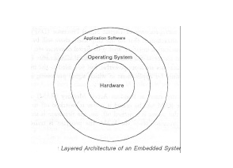Every embedded system consists of custom-built hardware built around a Central Processing Unit (CPU). This hardware also contains memory chips onto which the software is loaded. The software residing on the memory chip is also called the ‘firmware’. The embedded system architecture can be represented as a layered architecture as shown in Fig. The operating system runs above the hardware, and the application software runs above the operating system. The same architecture is applicable to any computer including a desktop computer. However, there are significant differences. It is not compulsory to have an operating system in every embedded system. For small appliances such as remote control units, air conditioners, toys etc., there is no need *for* an operating system and you can write only the software specific to that application. For applications involving complex processing, it is advisable to have an operating system. In such a case, you need to integrate the application software with the operating system and then transfer the entire software on to the memory chip. Once the software is transferred to the memory chip, the software will continue to run *for* a long time you don’t need to reload new software.

Now, let us see the details of the various building blocks of the hardware of an embedded system. As shown in Fig. the building blocks are;

· Central Processing Unit (CPU)

· Memory (Read-only Memory and Random Access Memory)

· Input Devices

· Output devices

· Communication interfaces

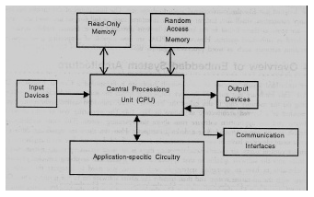· Application-specific circuitry

**Central Processing Unit (CPU):**

The Central Processing Unit (processor, in short) can be any of the following: microcontroller, microprocessor or Digital Signal Processor (DSP). A micro-controller is a low-cost processor. Its main attraction is that on the chip itself, there will be many other components such as memory, serial communication interface, analog-to digital converter etc. So, for small applications, a micro-controller is the best choice as the number of external components required will be very less. On the other hand, microprocessors are more powerful, but you need to use many external components with them. D5P is used mainly for applications in which signal processing is involved such as audio and video processing.

**Memory:**

The memory is categorized as Random Access Memory (RAM) and Read Only Memory (ROM). The contents of the RAM will be erased if power is switched off to the chip, whereas ROM retains the contents even if the power is switched off. So, the firmware is stored in the ROM. When power is switched on, the processor reads the ROM; the program is program is executed.

**Input Devices**:

Unlike the desktops, the input devices to an embedded system have very limited capability. There will be no keyboard or a mouse, and hence interacting with the embedded system is no easy task. Many embedded systems will have a small keypad-you press one key to give a specific command. A keypad may be used to input only the digits. Many embedded systems used in process control do not have any input device *for* user interaction; they take inputs *from* sensors or transducers 1’fnd produce electrical signals that are in turn fed to other systems.

**Output Devices**:

The output devices of the embedded systems also have very limited capability. Some embedded systems will have a *few* Light Emitting Diodes (LEDs) *to* indicate the health status of the system modules, or *for* visual indication of alarms. A small Liquid Crystal Display (LCD) may also be used to display *some* important parameters.

**Communication Interfaces**:

The embedded systems may need to, interact with other embedded systems at they may have to transmit data to a desktop. To facilitate this, the embedded systems are provided with one or a *few* communication interfaces such as RS232, RS422, RS485, Universal Serial Bus (USB), IEEE 1394, Ethernet etc.

**Application-Specific Circuitry**:

Sensors, transducers, special processing and control circuitry may be required fat an embedded system, depending on its application. This circuitry interacts with the processor to carry out the necessary work. The entire hardware has to be given power supply either through the 230 volts main supply or through a battery. The hardware has to design in such a way that the power consumption is minimized.

**2.2 BLOCK DIAGRAM**

**Raspberry Pi**

**IR Sensor**

**Power supply**

**IOT**

**Module**

**LCD**

**PIR**

**Sensor**

**Camera**

**Buzzer**

**Piezo Sensor**

**Sound**

**Sensor**

**2.3MODULES:**

**2.3.1 POWER SUPPLY**

The power supply section is the section which provide +5V for the components to work. IC LM7805 is used for providing a constant power of +5V.

The ac voltage, typically 220V, is connected to a transformer, which steps down that ac voltage down to the level of the desired dc output. A diode rectifier then provides a full-wave rectified voltage that is initially filtered by a simple capacitor filter to produce a dc voltage. This resulting dc voltage usually has some ripple or ac voltage variation.

A regulator circuit removes the ripples and also retains the same dc value even if the input dc voltage varies, or the load connected to the output dc voltage changes. This voltage regulation is usually obtained using one of the popular voltage regulator IC units.



Block Diagram Of Power Supply

**2.3.2 Transformer**

Transformers convert AC electricity from one voltage to another with little loss of power. Transformers work only with AC and this is one of the reasons why mains electricity is AC.

Step-up transformers increase voltage, step-down transformers reduce voltage. Most power supplies use a step-down transformer to reduce the dangerously high mains voltage (230V in India) to a safer low voltage.

The input coil is called the primary and the output coil is called the secondary. There is no electrical connection between the two coils; instead they are linked by an alternating magnetic field created in the soft-iron core of the transformer. Transformers waste very little power so the power out is (almost) equal to the power in. Note that as voltage is stepped down current is stepped up.

The transformer will step down the power supply voltage (0-230V) to (0- 6V) level. Then the secondary of the potential transformer will be connected to the bridge rectifier, which is constructed with the help of PN junction diodes. The advantages of using bridge rectifier are it will give peak voltage output as DC.

**2.3.3 Rectifier**

There are several ways of connecting diodes to make a rectifier to convert AC to DC. The bridge rectifier is the most important and it produces full-wave varying DC. A full-wave rectifier can also be made from just two diodes if a centre-tap transformer is used, but this method is rarely used now that diodes are cheaper. A single diode can be used as a rectifier but it only uses the positive (+) parts of the AC wave to produce half-wave varying Dc

**2.3.4 Bridge Rectifier**

When four diodes are connected as shown in figure, the circuit is called as bridge rectifier. The input to the circuit is applied to the diagonally opposite corners of the network, and the output is taken from the remaining two corners. Let us assume that the transformer is working properly and there is a positive potential, at point A and a negative potential at point B. the positive potential at point A will forward bias D3 and reverse bias D4.



Bridge Rectifier

The negative potential at point B will forward bias D1 and reverse D2. At this time D3 and D1 are forward biased and will allow current flow to pass through them; D4 and D2 are reverse biased and will block current flow.

One advantage of a bridge rectifier over a conventional full-wave rectifier is that with a given transformer the bridge rectifier produces a voltage output that is nearly twice that of the conventional full-wave circuit.

i. The main advantage of this bridge circuit is that it does not require a special centre tapped transformer, thereby reducing its size and cost.

ii. The single secondary winding is connected to one side of the diode bridge network and the load to the other side as shown below.

iii. The result is still a pulsating direct current but with double the frequency.

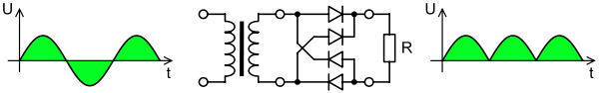

Output Waveform Of DC

**Smoothing**

Smoothing is performed by a large value electrolytic capacitor connected across the DC supply to act as a reservoir, supplying current to the output when the varying DC voltage from the rectifier is falling. The capacitor charges quickly near the peak of the varying DC, and then discharges as it supplies current to the output.

**2.3.5 Voltage Regulators**

Voltage regulators comprise a class of widely used ICs. Regulator IC units contain the circuitry for reference source, comparator amplifier, control device, and overload protection all in a single IC. IC units provide regulation of either a fixed positive voltage, a fixed negative voltage, or an adjustably set voltage. The regulators can be selected for operation with load currents from hundreds of milli amperes to tens of amperes, corresponding to power ratings from milli watts totens of watts.

A fixed three-terminal voltage regulator has an unregulated dc input voltage, Vi, applied to one input terminal, a regulated dc output voltage, Vo, from a second terminal, with the third terminal connected to ground.

The series 78 regulators provide fixed positive regulated voltages from 5 to 24 volts. Similarly, the series 79 regulators provide fixed negative regulated voltages from 5 to 24 volts. Voltage regulator ICs are available with fixed (typically 5, 12 and 15V) or variable output voltages. They are also rated by the maximum current they can pass. Negative voltage regulators are available, mainly for use in dual supplies. Most regulators include some automatic protection from excessive current ('overload protection') and overheating ('thermal protection').

Many of the fixed voltage regulator ICs has 3 leads and look like power transistors, such as the 7805 +5V 1Amp regulator. They include a hole for attaching a heat sink if necessary.



Regulator

 Circuit Diagram of Power Supply

**2.4 MICROCONTROLLER**

A Microcontroller (or MCU) is a computer-on-a-chip used to control electronic devices. It is a type of microprocessor emphasizing self-sufficiency and cost-effectiveness, in contrast to a general-purpose microprocessor (the kind used in a PC). A typical microcontroller contains all the memory and interfaces needed for a simple application, whereas a general purpose microprocessor requires additional chips to provide these functions.

A microcontroller is a single integrated circuit with the following key features:

1. central processing unit - ranging from small and simple 8-bit processors to sophisticated 32- or 64-bit processors
2. input/output interfaces such as serial ports
3. RAM for data storage
4. ROM, EEPROM or Flash memory for program storage
5. clock generator - often an oscillator for a quartz timing crystal, resonator or RC circuit

Microcontrollers are inside many kinds of electronic equipment (see embedded system). They are the vast majority of all processor chips sold. Over 50% are "simple" controllers, and another 20% are more specialized digital signal processors (DSPs) (ref?). A typical home in a developed country is likely to have only one or two general-purpose microprocessors but somewhere between one and two dozen microcontrollers. A typical mid-range vehicle has as many as 50 or more microcontrollers. They can also be found in almost any electrical device: washing machines, microwave ovens, telephones etc.

**2.4.1 RASPBERRY PI**

# INTRODUCTION

The Raspberry Pi is a series of credit card–sized single-board computers developed in the United Kingdom by the Raspberry Pi Foundation with the intention of promoting the teaching of basic computer science in schools and developing countries. The original Raspberry Pi and Raspberry Pi 2 are manufactured in several board configurations through licensed manufacturing agreements with Newark element14 (Premier Farnell), RS Components and Egoman. The hardware is the same across all manufacturers

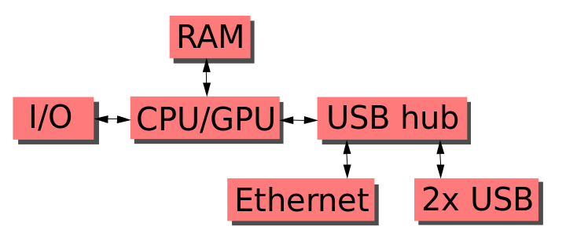

Fig 2.9Functional Block Schematic of the Raspberry-Pi

This block diagram depicts models A, B, A+, and B+. Model A and A+ and Zero lack the Ethernet and USB hub components. The Ethernet adapter is connected to an additional USB port. In model A and A+ the USB port is connected directly to the SoC. On model B+ the chip contains a five-point USB hub, of which four ports are available, while model B only provides two. On the model Zero, the USB port is also connected directly to the SoC, but it uses a micro USB (OTG) port.

Newer versions of the firmware contain the option to choose between five over clock ("turbo") presets that when turned on try to get the most performance out of the SoC without impairing the lifetime of the Pi. This is done by monitoring the core temperature of the chip, and the CPU load, and dynamically adjusting clock speeds and the core voltage. When the demand is low on the CPU, or it is running too hot, the performance is throttled, but if the CPU has much to do, and the chip's temperature is acceptable, performance is temporarily increased, with clock speeds of up to 1 GHz, depending on the individual board, and on which of the turbo settings is used. The five settings are:

* none; 700 MHz ARM, 250 MHz core, 400 MHz SDRAM, 0 overvolt,
* modest; 800 MHz ARM, 250 MHz core, 400 MHz SDRAM, 0 overvolt,
* medium; 900 MHz ARM, 250 MHz core, 450 MHz SDRAM, 2 overvolt,
* high; 950 MHz ARM, 250 MHz core, 450 MHz SDRAM, 6 overvolt,
* turbo; 1000 MHz ARM, 500 MHz core, 600 MHz SDRAM, 6 overvolt.

The Raspberry Pi has a Broadcom BCM2835 system on a chip (SoC), which includes an ARM1176JZF-S 700 MHz processor, Video Core IV GPU and was originally shipped with 256 megabytes of RAM, later upgraded (Model B & Model B+) to 512 MB. It does not include a built-in hard disk or solid-state drive, but it uses an SD card for booting and persistent storage, with the Model B+ using a Micro SD.

**Inception of Raspberry Pi**

The idea behind a tiny and affordable computer for kids came in 2006, when Eben Upton, Rob Mullins, Jack Lang and Alan Mycroft, based at the University of Cambridge’s Computer Laboratory, became concerned about the year-on-year decline in the numbers and skills levels of the A Level students applying to read Computer Science. From a situation in the 1990s where most of the kids applying were coming to interview as experienced hobbyist programmers, the landscape in the 2000s was very different; a typical applicant might only have done a little web design.

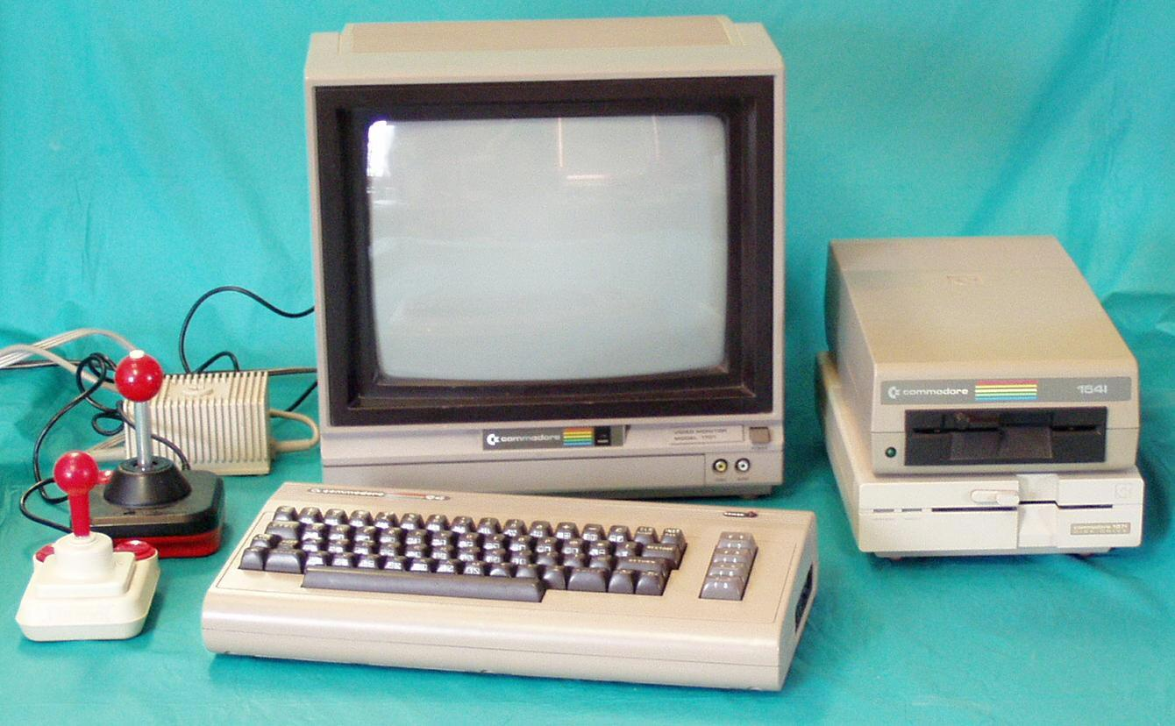

Figure 2.10.A complete Commodore 64 System

# Hardware Layout

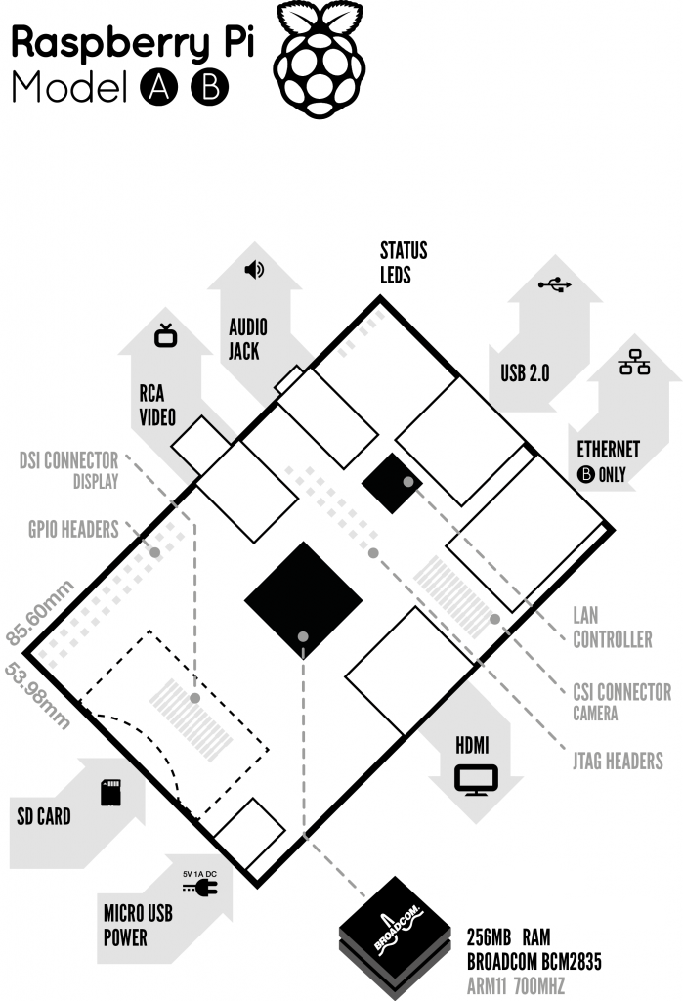

Figure 2.11 Block Diagram of Raspberry Pi

## Description of the Components on the Pi.

1. Processor / SoC (System on Chip)

The Raspberry Pi has a Broadcom BCM2835 System on Chip module. It has a ARM1176JZF-S processor. The Broadcom SoC used in the Raspberry Pi is equivalent to a chip used in an old Smartphone (Android or iPhone). While operating at 700 MHz by default, the Raspberry Pi provides a real world performance roughly equivalent to the 0.041 GFLOPS. On the CPU level the performance is similar to a 300 MHz Pentium II of 1997-1999, but the GPU, however, provides 1 Gpixel/s, 1.5 Gtexel/s or 24 GFLOPS of general purpose compute and the graphics capabilities of the Raspberry Pi are roughly equivalent to the level of performance of the Xbox of 2001. The Raspberry Pi chip operating at 700 MHz by default, will not become hot enough to need a heatsink or special cooling.

1. Power source

The Pi is a device which consumes 700mA or 3W or power. It is powered by a MicroUSB charger or the GPIO header. Any good smartphone charger will do the work of powering the Pi.

1. SD Card

The Raspberry Pi does not have any onboard storage available. The operating system is loaded on a SD card which is inserted on the SD card slot on the Raspberry Pi. The operating system can be loaded on the card using a card reader on any computer.

1. GPIO – General Purpose Input Output

General-purpose input/output (GPIO) is a generic pin on an integrated circuit whose behavior, including whether it is an input or output pin, can be controlled by the user at run time. GPIO pins have no special purpose defined, and go unused by default.

GPIO capabilities may include:

* GPIO pins can be configured to be input or output
* GPIO pins can be enabled/disabled
* Input values are readable (typically high=1, low=0)
* Output values are writable/readable
* Input values can often be used as IRQs (typically for wakeup events)

The production Raspberry Pi board has a 26-pin 2.54 mm (100 mil) expansion header, marked as P1, arranged in a 2x13 strip. They provide 8 GPIO pins plus access to I²C, SPI, UART), as well as +3.3 V, +5 V and GND supply lines. Pin one is the pin in the first column and on the bottom row.

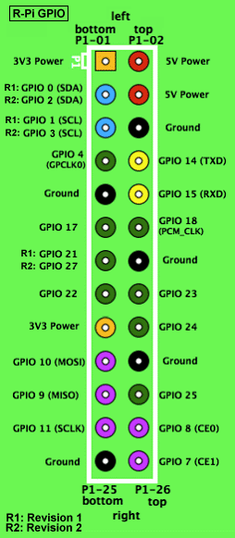

Figure 2.12: GPIO connector on RPi

1. DSI Connector

The Display Serial Interface (DSI) is a specification by the Mobile Industry Processor Interface (MIPI) Alliance aimed at reducing the cost of display controllers in a mobile device. It is commonly targeted at LCD and similar display technologies. It defines a serial bus and a communication protocol between the host (source of the image data) and the device (destination of the image data).

1. RCA Video

RCA Video outputs (PAL and NTSC) are available on all models of Raspberry Pi. Any television or screen with a RCA jack can be connected with the RPi.

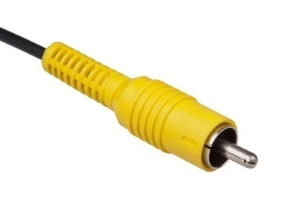

Figure2.13 RCA Video Connector

1. Audio Jack

A standard 3.5 mm TRS connector is available on the RPi for stereo audio output. Any headphone or 3.5mm audio cable can be connected directly. Although this jack cannot be used for taking audio input, USB mics or USB sound cards can be used.

1. Status LEDs

There are 5 status LEDs on the RPi that show the status of various activities as follows:

“OK” - SD Card Access (via GPIO16) - labeled as "OK" on Model B Rev1.0 boards and "ACT" on Model B Rev2.0 and Model A boards

“POWER” - 3.3 V Power - labeled as "PWR" on all boards

“FDX” - Full Duplex (LAN) **(Model B)** - labeled as "FDX" on all boards

“LNK” - Link/Activity (LAN) **(Model B)** - labeled as "LNK" on all boards

“10M/100” - 10/100Mbit (LAN) **(Model B)** - labeled (incorrectly) as "10M" on Model B Rev1.0 boards and "100" on Model B Rev2.0 and Model A boards

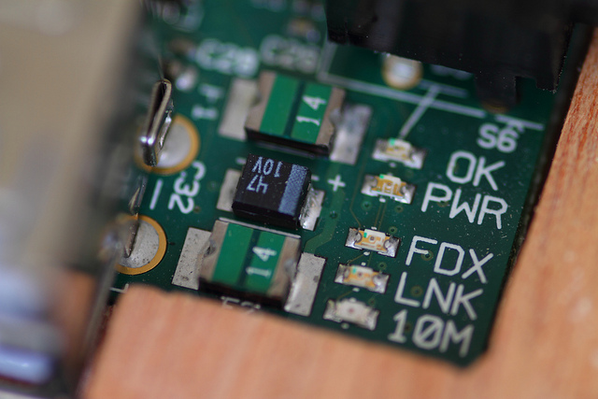

Figure 2.14 Status LEDs

1. USB 2.0 Port

USB 2.0 ports are the means to connect accessories such as mouse or keyboard to the Raspberry Pi. There is 1 port on Model A, 2 on Model B and 4 on Model B+. The number of ports can be increased by using an external powered USB hub which is available as a standard Pi accessory.

1. Ethernet

Ethernet port is available on Model B and B+. It can be connected to a network or internet using a standard LAN cable on the Ethernet port. The Ethernet ports are controlled by Microchip LAN9512 LAN controller chip.

1. CSI connector

CSI – Camera Serial Interface is a serial interface designed by MIPI (Mobile Industry Processor Interface) alliance aimed at interfacing digital cameras with a mobile processor. The RPi foundation provides a camera specially made for the Pi which can be connected with the Pi using the CSI connector.

1. JTAG headers

JTAG is an acronym for ‘Joint Test Action Group', an organization that started back in the mid 1980's to address test point access issues on PCB with surface mount devices. The organization devised a method of access to device pins via a serial port that became known as the TAP (Test Access Port). In 1990 the method became a recognized international standard (IEEE Std 1149.1). Many thousands of devices now include this standardized port as a feature to allow test and design engineers to access pins.

1. HDMI

HDMI – High Definition Multimedia Interface

HDMI 1.3 a type A port is provided on the RPi to connect with HDMI screens.

## SPECIFICATIONS

|  |  |  |  |
| --- | --- | --- | --- |
|  | **Model A** | **Model B** | **Model B+** |
| **Target price:** | US$25 | US$35 | |
| **SoC:** | Broadcom BCM2835 (CPU, GPU, DSP, SDRAM, and single USB port) | | |
| **CPU:** | 700 MHz ARM1176JZF-S core (ARM11 family, ARMv6 instruction set) | | |
| **GPU:** | Broadcom Video Core IV @ 250 MHz | | |
| **Memory (SDRAM):** | 256 MB (shared with GPU) | 512 MB (shared with GPU) as of 15 October 2012 | |
| **USB 2.0 ports:** | 1 (direct from BCM2835 chip) | 2 (via the on-board 3-port USB hub) | 4 (via the on-board 5-port USB hub) |
| **Video input:** | 15-pin MIPI camera interface (CSI) connector, used with the Raspberry Pi Camera Addon. | | |
| **Video outputs:** | Composite RCA (PAL and NTSC) –in model B+ via 4-pole 3.5 mm jack, HDMI (rev 1.3 & 1.4), raw LCD Panels via DS | | |
| **Audio outputs:** | 3.5 mm jack, HDMI, and, as of revision 2 boards, I²S audio (also potentially for audio input) | | |
| **Onboard storage:** | SD / MMC / SDIO card slot (3.3 V card power support only) | | Micro SD |
| **Onboard network:** | None | 10/100 Mbit/s Ethernet (8P8C) USB adapter on the third/fifth port of the USB hub | |
| **Low-level peripherals:** | 8× GPIO, UART, I²C bus, SPI bus with two chip selects, I²S audio +3.3 V, +5 V, ground | | 17× GPIO |
| **Power ratings:** | 300 mA (1.5 W) | 700 mA (3.5 W) | 600 mA (3.0 W) |
| **Power source:** | 5 V via MicroUSB or GPIO header | | |
| **Size:** | 85.60 mm × 56 mm (3.370 in × 2.205 in) – not including protruding connectors | | |
| **Weight:** | 45 g (1.6 oz) | | |

## Accessories

Raspberry Pi being a very cheap computer has attracted millions of users around the world. Thus it has a large user base. Many enthusiasts have created accessories and peripherals for the Raspberry Pi. This range from USB hubs, motor controllers to temperature sensors. There are some official accessories for the RPi as follows:

**Camera** – On 14 May 2013, the foundation and the distributors RS Components & Premier Farnell/Element 14 launched the Raspberry Pi camera board with a firmware update to support it. The Raspberry Pi camera board contains a 5 MPixel sensor, and connects via a ribbon cable to the CSI connector on the Raspberry Pi. In Raspbian support can be enabled by the installing or upgrading to the latest version of the OS and then running Raspi-config and selecting the camera option. The cost of the camera module is 20 EUR in Europe (9 September 2013). And supports 1080p, 720p, 640x480p video. The footprint dimensions are 25 mm x 20 mm x 9 mm.

**Gert board** – A Raspberry Pi Foundation sanctioned device designed for educational purposes, and expands the Raspberry Pi's GPIO pins to allow interface with and control of LEDs, switches, analog signals, sensors and other devices. It also includes an optional Arduino compatible controller to interface with the Pi. The Gertboard can be used to control motors, switches etc. for robotic projects.

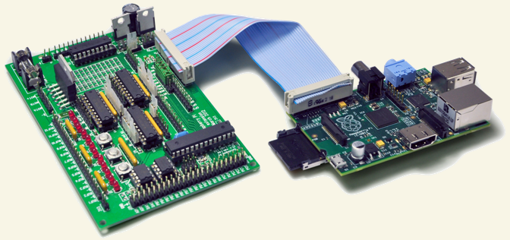

Figure 2.15: Gertboard (left) & Raspberry Pi(Right)

**USB Hub** – Although not an official accessory, it is a highly recommended accessory for the Pi. A powered USB Hub with 7 extra ports is available at almost all online stores. It is compulsory to use a USB Hub to connect external hard disks or other accessories that draw power from the USB ports, as the Pi cannot give power to them.

## Comparison of Raspberry with the competitors

The chief competitors of the Raspberry Pi are the Arduino and the Beagle board. Both are single board computers and have applications similar to the Raspberry Pi. A brief comparison of the three of them is shown below:

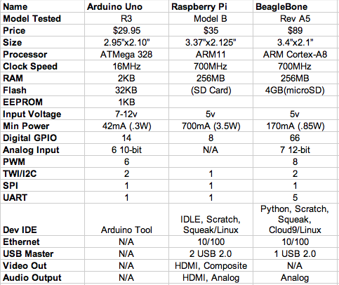

Table 2.2: Comparison of RPi with chief competitors

**2.5 LIQUID CRYSTAL DISPLAY (LCD)**

LCD (Liquid Crystal Display) screen is an electronic display module and find a wide range of applications. A 16x2 LCD display is very basic module and is very commonly used in various devices and circuits. These modules are preferred over [seven segments](http://www.engineersgarage.com/content/seven-segment-display) and other multi segment [LED](http://www.engineersgarage.com/content/led)s. The reasons being: LCDs are economical; easily programmable; have no limitation of displaying special & even [custom characters](http://www.engineersgarage.com/microcontroller/8051projects/create-custom-characters-LCD-AT89C51) (unlike in seven segments), [animations](http://www.engineersgarage.com/microcontroller/8051projects/display-custom-animations-LCD-AT89C51) and so on.

A **16x2 LCD** means it can display 16 characters per line and there are 2 such lines. In this LCD each character is displayed in 5x7 pixel matrix. This LCD has two registers, namely, Command and Data.

The command register stores the command instructions given to the LCD. A command is an instruction given to LCD to do a predefined task like initializing it, clearing its screen, setting the cursor position, controlling display etc. The data register stores the data to be displayed on the LCD. The data is the ASCII value of the character to be displayed on the LCD.

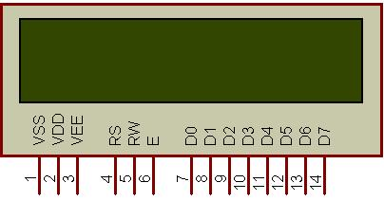

Fig. 16x2 LCD

**2.5.1 Introduction**

The most commonly used Character based LCDs are based on Hitachi's HD44780 controller or other which are compatible with HD44580.

**2.5.2 Pin Description**

Most LCDs with 1 controller has 14 Pins and LCDs with 2 controller has 16 Pins (two pins are extra in both for back-light LED connections). Pin description is shown in the table below.

**Pin Configuration table for a 16X2 LCD character display:-**

|  |  |  |
| --- | --- | --- |
| **Pin Number** | **Symbol** | **Function** |
| **1** | Vss | Ground Terminal |
| **2** | Vcc | Positive Supply |
| **3** | Vdd | Contrast adjustment |
| **4** | RS | Register Select; 0→Instruction Register, 1→Data Register |
| **5** | R/W | Read/write Signal; 1→Read, 0→ Write |
| **6** | E | Enable; Falling edge |
| **7** | DB0 | Bi-directional data bus, data transfer is performed once, thru DB0 to DB7, in the case of interface data length is 8-bits; and twice, through DB4 to DB7 in the case of interface data length is 4-bits. Upper four bits first then lower four bits. |
| **8** | DB1 |
| **9** | DB2 |
| **10** | DB3 |
| **11** | DB4 |
| **12** | DB5 |
| **13** | DB6 |
| **14** | DB7 |
| **15** | LED-(K) | Back light LED cathode terminal |
| **16** | LED+(A) | Back Light LED anode terminal |

Table Pin Description of LCD

**Data/Signals/Execution of LCD**

Coming to data, signals and execution.

LCD accepts two types of signals, one is data, and another is control. These signals are recognized by the LCD module from status of the RS pin. Now data can be read also from the LCD display, by pulling the R/W pin high. As soon as the E pin is pulsed, LCD display reads data at the falling edge of the pulse and executes it, same for the case of transmission.

                LCD display takes a time of 39-43µS to place a character or execute a command. Except for clearing display and to seek cursor to home position it takes 1.53ms to 1.64ms. Any attempt to send any data before this interval may lead to failure to read data or execution of the current data in some devices. Some devices compensate the speed by storing the incoming data to some temporary registers.

**Instruction Register (IR) and Data Register (DR)**

There are two 8-bit registers in HD44780 controller Instruction and Data register. Instruction register corresponds to the register where you send commands to LCD e.g LCD shift command, LCD clear, LCD address etc. and Data register is used for storing data which is to be displayed on LCD. when send the enable signal of the LCD is asserted, the data on the pins is latched in to the data register and data is then moved automatically to the DDRAM and hence is displayed on the LCD. Data Register is not only used for sending data to DDRAM but also for CGRAM, the address where you want to send the data, is decided by the instruction you send to LCD. We will discuss more on LCD instruction set further in this tutorial.

**Commands and Instruction set**

Only the instruction register (IR) and the data register (DR) of the LCD can be controlled by the MCU. Before starting the internal operation of the LCD, control information is temporarily stored into these registers to allow interfacing with various MCUs, which operate at different speeds, or various peripheral control devices. The internal operation of the LCD is determined by signals sent from the MCU. These signals, which include register selection signal (RS), read/write signal (R/W), and the data bus (DB0 to DB7), make up the LCD instructions (Table 3). There are four categories of instructions that:

* Designate LCD functions, such as display format, data length, etc.
* Set internal RAM addresses
* Perform data transfer with internal RAM
* Perform miscellaneous functions

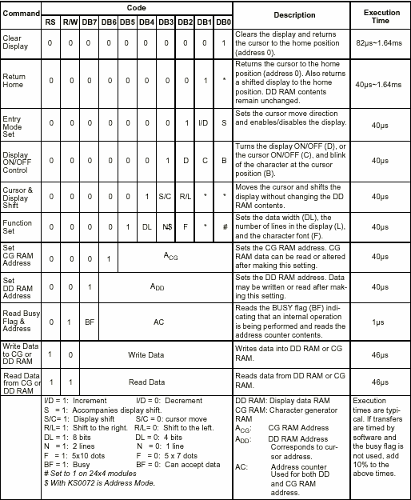

Table Showing various LCD Command Description

Although looking at the table you can make your own commands and test them. Below is a brief list of useful commands which are used frequently while working on the LCD.

**2.5.3 List of Command**

|  |  |  |  |
| --- | --- | --- | --- |
| **No.** | **Instruction** | **Hex** | **Decimal** |
| 1 | Function Set: 8-bit, 1 Line, 5x7 Dots | 0x30 | 48 |
| 2 | Function Set: 8-bit, 2 Line, 5x7 Dots | 0x38 | 56 |
| 3 | Function Set: 4-bit, 1 Line, 5x7 Dots | 0x20 | 32 |
| 4 | Function Set: 4-bit, 2 Line, 5x7 Dots | 0x28 | 40 |
| 5 | Entry Mode | 0x06 | 6 |
| 6 | Display off Cursor off (clearing display without clearing DDRAM content) | 0x08 | 8 |
| 7 | Display on Cursor on | 0x0E | 14 |
| 8 | Display on Cursor off | 0x0C | 12 |
| 9 | Display on Cursor blinking | 0x0F | 15 |
| 10 | Shift entire display left | 0x18 | 24 |
| 12 | Shift entire display right | 0x1C | 30 |
| 13 | Move cursor left by one character | 0x10 | 16 |
| 14 | Move cursor right by one character | 0x14 | 20 |
| 15 | Clear Display (also clear DDRAM content) | 0x01 | 1 |
| 16 | Set DDRAM address or courser position on display | 0x80+add* | 128+add* |
| 17 | Set CGRAM address or set pointer to CGRAM location | 0x40+add** | 64+add** |

Table: Frequently Used Commands and Instructions for LCD

* DDRAM address given in LCD basics section see Figure 2,3,4  
** CGRAM address from 0x00 to 0x3F, 0x00 to 0x07 for char1 and so on.

**Liquid crystal displays interfacing with Controller**

The LCD standard requires 3 control lines and 8 I/O lines for the data bus.

• **8 data pins D7:D0**

Bi-directional data/command pins.  
Alphanumeric characters are sent in ASCII format.

• **RS:  Register Select**

RS = 0 -> Command Register is selected  
RS = 1 -> Data Register is selected

• **R/W: Read or Write**

0 -> Write, 1 -> Read

• **E: Enable (Latch data)**

Used to latch the data present on the data pins.  
A high-to-low edge is needed to latch the data.

**2.6 IOT (INTERNET OF THINGS)**

Internet of things (IOT), is another advance technology in IT sector, provides internetworking for numerous of devices such as sensors, actuators, PLCs and other electronic embedded smart devices and controls, and various software’s’ and provides systems network configuration and connectivity, which enables communication between these numerous devices for information exchanging.

In 1995, “thing to thing” was coined by BILL GATES. In 1999, IOT (Internet of Things) was come up by EPC global. IOT interconnects human to thing, thing to thing and human to human. The goal of IOT is bring out a huge network by combining different types connected devices. IOT targets three aspects Communication, automation, cost saving in a system. IOT empowers people to carry out routine activities using internet and thus saves time and cost making them more productive. IOT enables the objects to be sensed and/or controlled remotely across existing network model. IOT in environmental monitoring helps to know about the air and water quality, temperature and conditions of the soil, and also monitor the intrusion of animals in to the field. IOT can also play a significant role in precision farming to enhance the productivity of the farm.

Recent advancements, such as the vision of the Internet of Things (IOT), the cloud computing model, and cyber-physical systems, provide support for the transmission and management of huge amounts of data regarding the trends observed in environmental parameters. In this context, the current work presents three different IOT-based wireless sensors

For environmental and ambient monitoring: one employing User Datagram Protocol (UDP)-based Wi-Fi communication, one communicating through Wi-Fi and Hypertext Transfer Protocol (HTTP), and a third one using Bluetooth Smart. All of the presented systems provide the possibility of recording data at remote locations and of visualizing them from every device with an Internet connection, enabling the monitoring of geographically large areas. The development details of these systems are described, along with the major differences and similarities between them. The feasibility of the three developed systems for implementing monitoring applications, taking into account their energy autonomy, ease of use, solution complexity, and Internet connectivity facility, was analysed, and revealed that they make good candidates for IOT-based solutions.

Nowadays, IOT is one of the most advanced, efficient, and cost less technological solution which encompasses various hardware and software resources; and allows remotely connected sensing devices to sense with more capabilities, provides efficiency and can be monitored and controlled through deployed of existing systems or infrastructures, resulting the physical World integration with computer controllers (or systems).

As IOT provides interconnectivity among various real-time sensing sensors and PLC and other intelligent devices, therefore this technology will be an entity indicated for the more advance cyber-systems encircling the significant developments, “such as smart grid, smart vehicle systems, smart medical systems, smart cities, and others smart systems.” In early future, IOT has striven to provide advance or smart connectivity for variety of electronic and intelligent equipment’s or devices, IT-based systems and the more advanced services through deploying of various traditional and real-time protocols, networks domains, and system software/hardware applications, which will be an work followed by machine-to-machine technological concept.

Through interconnection of various devices and managing ofThe **internet of things** (**IOT**) is the network of physical devices, vehicles, buildings and other items embedded with electronics, software, sensors, actuators, and network connectivity that enable these objects to collect and exchange data. In 2013 the Global Standards Initiative on Internet of Things (IOT-GSI) defined the IOT as "the infrastructure of the information society. The IOT allows objects to be sensed and controlled remotely across existing network infrastructure, creating opportunities for more direct integration of the physical world into computer-based systems, and resulting in improved efficiency, accuracy and economic benefit.

When IOT is augmented with sensors and actuators, the technology becomes an instance of the more general class of cyber-physical systems, which also encompasses technologies such as smart grids, smart homes, intelligent transportation and smart cities. Each thing is uniquely identifiable through its embedded computing system but is able to interoperate within the existing Internet infrastructure. Experts estimate that the IOT will consist of almost 50 billion objects by 2020.

IOT is a system defines an environment that encompasses numerous of objects; sensors that connected with these objects are accessible over the Internet through employing of various

Networks connections, such wired or wireless. IOT can be able to carry information from various embedded sensors attached with the physical World, human and any inanimate object, and then transmit them to a system for further analyses. In early future, IOT will be able to connect almost components or parts of industrial infrastructures, smart medical telemonitoring systems, and smart transportation systems; and will provide the information sharing facilities in order to make systems and peoples always updated.

**2.6.1 ESP8266 WIFI IOT MODULE**

**Description:**

* These modules include 1MB (8Mbit) of flash memory, twice the size of the older blue colored ESP-01 module
* The ESP8266 Serial/UART to WiFi module is a great way to connect your Arduino or other microcontroller projects to a WiFi network
* Create your next internet of things (IOT) project with affordable network connectivity by implementing this module into your design
* The module has the ability to run independent of a host controller
* The eight pin header includes two GPIO pins that allow for direct connection of the module to sensors, peripherals, or host controller
* Check out our [ESP8266 breadboard adapter](https://www.addicore.com/product-p/ad-bb-adtr.htm) to use your ESP8266 module with a breadboard
* The ESP8266 has 3.6V tolerant I/Os so you will need a [logic level converter](https://www.addicore.com/product-p/227.htm) to connect it with higher voltage devices such as Arduino
* The ESP8266 requires 3.3V power so you may need a [3.3V voltage regulator](https://www.addicore.com/product-p/165.htm) to provide the correct voltage, depending on your setup

**Product Contents:**

* 1 — ESP8266 ESP-01 WiFi Tranceiver Module with baud rate set at 115200 bps
* 1 (per order) — Addicore ESP8266 info card (includes pinout diagram)

**Specifications:**

* 802.11 b/g/n
* Serial/UART baud rate: 115200 bps
* Integrated TCP/IP protocol stack
* Input power: 3.3V (see "Recommended Accessories" below for 3.3V power options)
* I/O voltage tolerance: 3.6V Max (see "Recommended Accessories" below for level converters to connect to higher voltage devices (i.e. Arduino) )
* Regular operation current draw: ~70mA
* Peak operating current draw: ~300mA
* Power down leakage current: <10µA
* +19.5dBm output in 802.11b mode
* Flash Memory Size: 1MB (8Mbit)
* WiFi security modes: WPA, WPA2
* Module's dimensions: 24.75mm x 14.5mm (0.974" x 0.571")

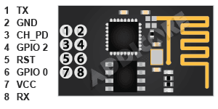

**2.7 BUZZER**

A [buzzer](http://www.microbuzzer.com/) or beeper is a signaling device, usually electronic, typically used in automobiles, house hold appliances such as a microwave oven, or game shows.

It most commonly consists of a number of switches or sensors connected to a control unit that determines if and which button was pushed or a preset time has lapsed, and usually illuminates a light on the appropriate button or control panel, and sounds a warning in the form of a continuous or intermittent buzzing or beeping sound. Initially this device was based on an electromechanical system which was identical to an electric bell without the metal gong (which makes the ringing noise). Often these units were anchored to a wall or ceiling and used the ceiling or wall as a sounding board. Another implementation with some AC-connected devices was to implement a circuit to make the AC current into a noise loud enough to drive a loudspeaker and hook this circuit up to a cheap 8-ohm speaker. Nowadays, it is more popular to use a ceramic-based piezoelectric sounder like a Sonalert which makes a high-pitched tone. Usually these were hooked up to “driver” circuits which varied the pitch of the sound or pulsed the sound on and off.

In game shows it is also known as a “lockout system,” because when one person signals (“buzzes in”), all others are locked out from signalling. Several game shows have large buzzer buttons which are identified as “plungers”.

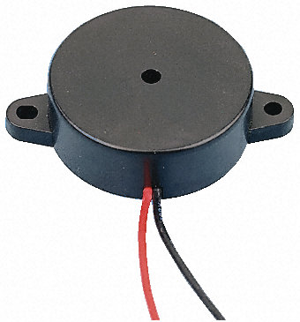

Fig. Buzzer

**USES**

* [Annunciator panels](http://en.wikipedia.org/wiki/Annunciator_panel)
* Electronic [metronomes](http://en.wikipedia.org/wiki/Metronome)
* [Game shows](http://en.wikipedia.org/wiki/Game_show)
* [Microwave ovens](http://en.wikipedia.org/wiki/Microwave_oven) and other [household appliances](http://en.wikipedia.org/wiki/Major_appliance)
* [Sporting](http://en.wikipedia.org/wiki/Sport) events such as [basketball](http://en.wikipedia.org/wiki/Basketball) games
* Electrical [alarms](http://en.wikipedia.org/wiki/Alarms)

**2.8 CAMERA**

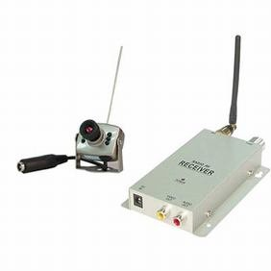

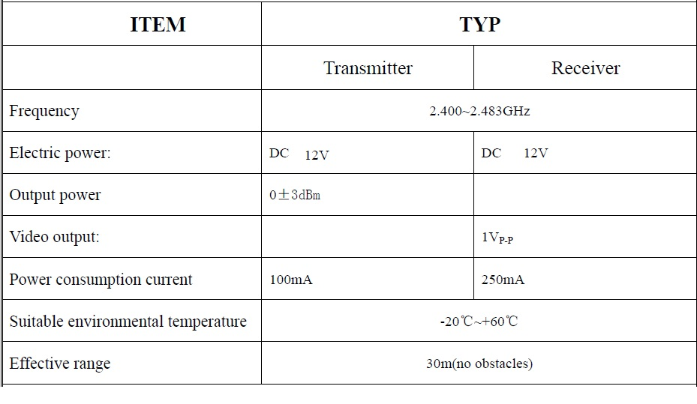

**Operation instruction**

1. Connecting receive antenna (figure 1).

2. Connecting 12V direct current stabilizer, pilot lamp lighting

3. Connecting the audio and video output with the input of monitor, the television should be in AV model.

4. Connecting the regulated voltage power supply to the back of the wireless camera.

5. Tuning the 4ch switch on receiver till receiving the picture of the wireless video camera.

6. Manually adjust the camera angle as well as the front lens of the camera.

**2.9 IR SENSOR**

IR sensor  is very useful if you are trying to make a obstacle avoider robot or a line follower. In this project we are going to make a simple IR sensor which can detect a object around 6-7 cm. IR sensor is nothing but a diode, which is sensitive for infrared radiation. This infrared transmitter and receiver is called as IR TX-RX pair.

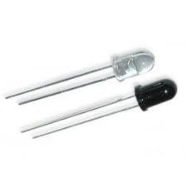

Fig. IR Sensor

**FEATURES**

* Fast response time
* Because it have good range which is fulfill our requirements.
* It is very low cost and can be constructed on general purpose.
* It is of very small size.
* You can increase numbers of transmitter as you want for good result
* Good immunity to ambient light and waves are invisible to eyes.

**WORKING OF IR**

Working of IR sensor is very simple and working principle is totally based on change in resistance of IR receiver. Here in this sensor we connect IR receiver in reverse bias so it give very high resistance if it is not exposed to IR light. the resistance in this case is in range of Mega ohms, but when IR light reflected back and fall  on  IR receiver. The resistance of Rx it comes in range between  Kilo ohms to hundred of ohms. We convert this change in resistance to change in voltage . Then this voltage is applied to a comparator IC which compare it with a threshold level. if voltage of sensor is more than threshold then output is high else it is low which can be used directly for  [microcontroller](http://tentuts.meritox.com/2012/05/how-to-make-ir-sensor-modules-using.html).

**Applications**

Infrared radiation is the region of the electromagnetic spectrum between microwaves and visible light. In infrared communication an LED transmits the infrared signal as bursts of non-visible light. At the receiving end a photodiode or photoreceptor detects and captures the light pulses, which are then processed to retrieve the information they contain. Some common applications of infrared technology are listed below.

1. Augmentative communication devices
2. Car locking systems
3. Computers  
   a. Mouse  
   b. Keyboards  
   c. Floppy disk drives  
   d. Printers
4. Emergency response systems
5. Environmental control systems  
   a. Windows  
   b. Doors  
   c. Lights  
   d. Curtains  
   e. Beds  
   f. Radios
6. Headphones
7. Home security systems
8. Navigation systems
9. Signage
10. Telephones
11. TVs, VCRs, CD players, stereos.

**2.10 PIEZO SENSOR**

A [sensor](https://www.watelectronics.com/different-types-of-sensors-with-applications/) that utilizes the piezoelectric effect, to measure changes in acceleration, strain, pressure, and force by converting them into electrical charge is called as a piezoelectric sensor. Piezo is a Greek word which means ‘press’ or ‘squeeze’. Piezoelectric effect causes the occurrence of electric dipole moments in solids due to the pressure applied to certain solid materials such as piezoelectric crystals, ceramics, bone, DNA, and some proteins that generates electric charge. This generated piezoelectricity is proportional to the pressure applied to the solid piezoelectric crystal materials. In this article, we will discuss about one of the most frequently used piezoelectric sensor applications, that is, piezo sensor switch.

Piezo Sensor Switch

[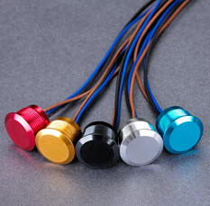](http://www.edgefx.in/wp-content/uploads/2014/10/piezo-switch-feature-image1.jpg)

**Piezo Sensor Switch**

An electrical switch that works based on the principle of piezoelectric effect is called as a piezo sensor switch. The Piezoelectric sensor switch can be turned on, by activating the output of semiconductor device such as a field effect transistor. This can be done using the charge generated by the pressure applied to the piezoelectric sensor element. If the field effect transistor is on, then current will flow through the FET acting as a metal contact-based switch. If the voltage pulse in the gate resistor is dissipated, then the FET turns off or turns into its regular high impedance state.

Piezoelectric Sensor Switch Circuit Working Procedure

We know that piezoelectric sensors generate an electric charge proportional to the pressure applied to certain materials. But, in case of piezoelectric sensor switches, typically the disc-shaped piezo element tend to bend very slightly like a drumhead due to the force or compressive pressure applied to certain materials. The voltage generated due to a single on pulse, produced by the pressure applied to the piezo switch can be varied by varying the amount of pressure. If the pressure applied to the piezoelectric sensor switch is increased, then higher voltages can be generated, which take a long time for dissipation.

[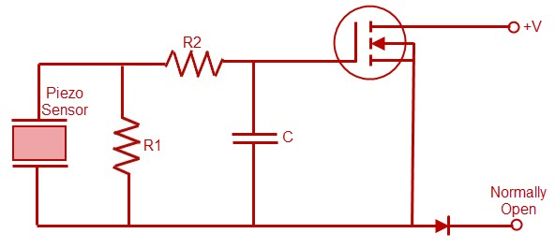](http://www.edgefx.in/wp-content/uploads/2014/10/piezo-switch.jpg)

**Piezo Switch Internal Circuit**

We can also increase the pulse width by lengthening the time constant of the gate circuit using a capacitor that stores charge. If we use a flip-flop, then by toggling flip-flop, we can change the output state from steady off to steady on. Compared to conventional mechanical switches the piezoelectric sensor switches don’t have moving parts, but the front plate and piezo element get little deformed typically by a few micrometers. As there are no moving parts, the lifetime of the piezoelectric sensor switch is more and these switches can be used for tens of millions of operations.

[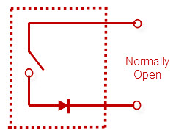](http://www.edgefx.in/wp-content/uploads/2014/10/piezo-open-switch1.jpg)

**Piezo Sensor Equivalent Circuit**

These piezoelectric sensor switches are weatherproof as they are completely sealed from the environment. As, stainless steel is used for construction of piezo sensor switches, they can withstand the damage and are resistant to heavy use.

The piezoelectric sensor switch is an alternative for impact or vibration detection and momentary switch applications. Strain is induced on the laminated piezo film sensor element due to the direct contact of the force applied to the stainless steel cantilever beam. Piezoelectric sensor element will generate an output that activates a normally opened, built-in circuit. If a circuit is activated, then it resembles a contact switch closure and due to corrosion, bouncing and pitting the contact points exhibits.

Thus, a single digital pulse is provided for triggering digital circuits. Because of the features like improved reliability and elasticity of the piezoelectric sensor element, it is suitable for applications demanding reliability and consistency in performance for tens of millions of cycles of operations.

Pressure is applied to the surface of the piezoelectric sensor switch that deflects about 2microns and this applied pressure is converted into an electrical signal by the piezoelectric crystal. This electrical signal generated by the piezoelectric sensor material is given to the electronics embedded in the piezoelectric sensor switch housing for amplification.

Piezo Knock Sensor Switch Circuit Working

Piezo knock sensor generates voltage proportional to the amount of stress, such as vibration or knock applied to piezoelectric crystal. It is used to detect knocks and hence it is also called as a piezo knock sensor. Piezo knock sensor Switch can be implemented using [Arduino board based real time project](https://www.watelectronics.com/arduino-uno-board-tutorial-and-its-applications/).

[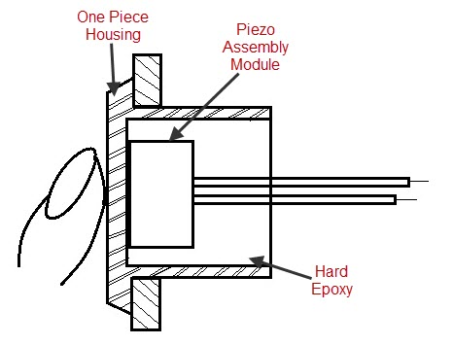](http://www.edgefx.in/wp-content/uploads/2014/10/piezo-switch-cross-section1.jpg)

**Piezo Sensor Switch Cross Sectional View**

It is a polarized electronic component, which consists of two leads: one positive and the other negative lead that are connected with a 1M ohm resistor between them.

**2.11 PASSIVE INFRA-RED SENSOR**

**Introduction**

A Passive Infrared sensor (PIR sensor) is an [electronic device](http://en.wikipedia.org/wiki/Electronic_device) that measures [infrared](http://en.wikipedia.org/wiki/Infrared) (IR) light radiating from objects in its field of view. PIR sensors are often used in the construction of PIR-based [motion detectors](http://en.wikipedia.org/wiki/Motion_detector). Apparent motion is detected when an infrared source with one [temperature](http://en.wikipedia.org/wiki/Temperature), such as a [human](http://en.wikipedia.org/wiki/Human), passes in front of an infrared source with another temperature, such as a [wall](http://en.wikipedia.org/wiki/Wall).

All objects emit what is known as [black body radiation](http://en.wikipedia.org/wiki/Black_body_radiation). It is usually infrared radiation that is invisible to the human [eye](http://en.wikipedia.org/wiki/Eye) but can be detected by [electronic devices](http://en.wikipedia.org/wiki/Electronic_device) designed for such a purpose. The term passive in this instance means that the PIR device does not emit an infrared beam but merely passively accepts incoming infrared radiation. “Infra” meaning below our ability to detect it visually, and “Red” because this color represents the lowest energy level that our eyes can sense before it becomes invisible. Thus, infrared means below the energy level of the color red, and applies to many sources of invisible energy.

Infrared radiation enters through the front of the sensor, known as the sensor face. At the core of a PIR sensor is a [solid state](http://en.wikipedia.org/wiki/Solid_state) [sensor](http://en.wikipedia.org/wiki/Sensor) or set of sensors, made from an approximately 1/4 [inch](http://en.wikipedia.org/wiki/Inch) square of natural or artificial [pyroelectric materials](http://en.wikipedia.org/wiki/Pyroelectricity), usually in the form of a [thin film](http://en.wikipedia.org/wiki/Thin_film), out of [gallium nitride](http://en.wikipedia.org/wiki/Gallium_nitride) (GaN), [caesium nitrate](http://en.wikipedia.org/wiki/Caesium_nitrate) (CsNO3), [polyvinyl fluorides](http://en.wikipedia.org/wiki/Polyvinyl_fluoride), derivatives of [phenylpyrazine](http://en.wikipedia.org/w/index.php?title=Phenylpyrazine&action=edit&redlink=1), and [cobalt](http://en.wikipedia.org/wiki/Cobalt)[phthalocyanine](http://en.wikipedia.org/wiki/Phthalocyanine). [Lithium tantalate](http://en.wikipedia.org/wiki/Lithium_tantalate) (LiTaO3) is a [crystal](http://en.wikipedia.org/wiki/Crystal) exhibiting both [piezoelectric](http://en.wikipedia.org/wiki/Piezoelectric) and pyroelectric properties.

The sensor is often manufactured as part of an integrated circuit and may consist of one (1), two (2) or four (4) 'pixels' of equal areas of the pyroelectric material. Pairs of the sensor pixels may be wired as opposite inputs to a differential amplifier. In such a configuration, the PIR measurements cancel each other so that the average temperature of the field of view is removed from the electrical signal; an increase of IR energy across the entire sensor is self-cancelling and will not trigger the device. This allows the device to resist false indications of change in the event of being exposed to flashes of light or field-wide illumination. (Continuous bright light could still saturate the sensor materials and render the sensor unable to register further information.) At the same time, this differential arrangement minimizes common-mode interference, allowing the device to resist triggering due to nearby electric fields. However, a differential pair of sensors cannot measure temperature in that configuration and therefore this configuration is specialized for motiondetectors.

**PIR Sensor**

This PIR (Passive Infra-Red) Sensor is a pyroelectric device that detects motion by measuring changes in the infrared (heat) levels emitted by surrounding objects. This motion can be detected by checking for a sudden change in the surrounding IR patterns. When motion is detected the PIR sensor outputs a high signal on its output pin. This logic signal can be read by a microcontroller or used to drive a transistor to switch a higher current load.

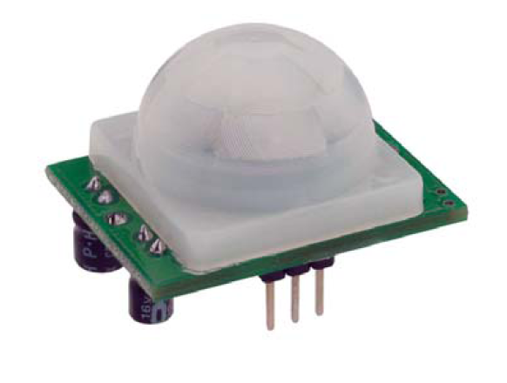

**Figure: 5.2.1 PIR Sensor Module\**

**Features**

Detection range up to 20 feet away Single bit output Jumper selects single or continuous trigger output mode 3-pin SIP header ready for breadboard or through hole. Product size makes it easy to conceal Compatible with BASIC Stamp, Propeller, and many other microcontrollers.

**Key Specifications**

* Power requirements: 3.3 to 5 VDC; >3 mA (may vary)
* Communication: Single bit high/low output
* Operating temperature: 32 to 122 °F (0 to 50 °C)
* Dimensions: 1.27 x 0.96 x 1.0 in (32.2 x 24.3 x 25.4 mm)

**Theory of Operation**

Pyroelectric devices, such as the PIR sensor, have elements made of a crystalline material that generates an electric charge when exposed to infrared radiation. The changes in the amount of infrared striking the element change the voltages generated, which are measured by an on-board amplifier. The device contains a special filter called a Fresnel lens, which focuses the infrared signals onto the element. As the ambient infrared signals change rapidly, the on-board amplifier trips the output to indicate motion.

**PIR pin definition and ratings:**

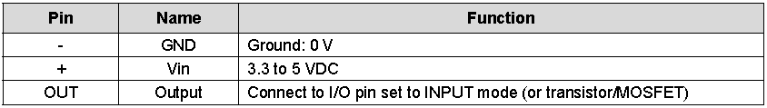

**Table: 5.5.1 Pin configuration of PIR Sensor**

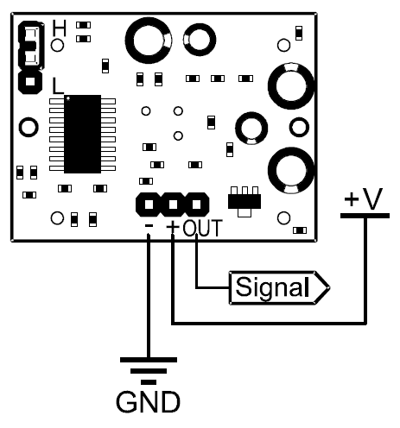

**Fig. Pin diagram of PIR Sensor**

**2.12 SOUND SENSOR**

The sound [sensor is one type of module](https://www.elprocus.com/map-sensor-working-and-its-applications/) used to notice the sound. Generally, this module is used to detect the intensity of sound. The applications of this module mainly include switch, security, as well as [monitoring](https://www.elprocus.com/wireless-monitoring-hardware-for-insightcm-by-national-instruments/). The accuracy of this sensor can be changed for the ease of usage.

This sensor employs a microphone to provide input to buffer, peak detector and an amplifier. This sensor notices a sound, & processes an o/p voltage signal to a microcontroller. After that, it executes required processing.

This sensor is capable to determine noise levels within DB’s or decibels at 3 kHz 6 kHz frequencies approximately wherever the human ear is sensitive. In smartphones, there is an android application namely decibel meter used to measure the sound level.

### **Sound Sensor Pin Configuration**

This sensor includes three pins which include the following.

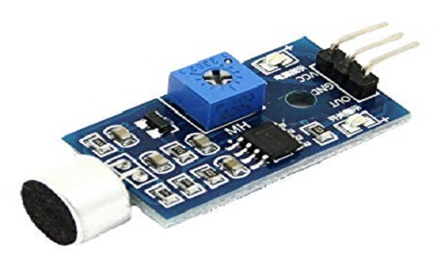

Fig: sound sensor

Pin1 (VCC): 3.3V DC to 5V DC

* Pin2 (GND): This is aground pin
* Pin3 (DO): This is an output pin

### **Working Principle**

The working principle of this sensor is related to human ears. Because human eye includes a diaphragm and the main function of this [diaphragm](https://www.elprocus.com/diaphragm-pump-types-and-applications/) is, it uses the vibrations and changes into signals. Whereas in this sensor, it uses a microphone and the main function of this is, it uses the vibrations and changes into current otherwise voltage.

Generally, it includes a diaphragm which is designed with magnets that are twisted with metal wire. When sound signals hit the diaphragm, then magnets within the sensor vibrates & simultaneously current can be stimulated from the coils.

### **Features**

The features of the sound sensor include the following

* These sensors are very simple to use
* It gives analog o/p signal
* Simply incorporates using logic modules on the input area

### **Specifications**

The specifications of the sound sensor include the following

* The range of operating voltage is 3.⅗ V
* The operating current is 4~5 mA
* The voltage gain 26 dB ((V=6V, f=1kHz)
* The sensitivity of the microphone (1kHz) is 52 to 48 dB
* The impedance of the microphone is 2.2k Ohm
* The frequency of m microphone is16 to 20 kHz
* The signal to noise ratio is 54 dB

### **Applications**

The applications of the sound sensor include the following.

This sensor can be used to build various[electronic projects](https://www.elprocus.com/build-simple-electronic-projects-using-breadboard/) with the help of an Arduino board. For instance, this project uses a grove sensor, which fundamentally gives your Arduino’s ears. In this project, a microphone can be attached to an analog pin of the board. This can be used to notice the noise level within the nearby surroundings.

The grove sensors support platforms like Arduino, Raspberry Pi, BeagleBone Wio, and LinkIt ONE. This sensor plays an essential role while activating the light in your office or house by detecting a precise whistle or clap sound.

Some more applications of this sensor include the following.

* Security system for Office or Home
* Spy Circuit
* [Home Automation](https://www.elprocus.com/wireless-home-automation-using-internet-of-things/)
* [Robotics](https://www.elprocus.com/embedded-robotics-real-time-robotic-applications-on-embedded-systems/)
* Smart Phones
* Ambient sound recognition
* Audio amplifier
* Sound level recognition (not capable to obtain precise dB value)

**CHAPTER 3**

**SOFTWARE SPECIFICATIONS**

**3.1 RASPBERRY PI SOFTWARE**

## OPERATING SYSTEM

The Raspberry Pi primarily uses Linux kernel-based operating systems. The ARM11 is based on version 6 of the ARM which is no longer supported by several popular versions of Linux, including Ubuntu. The install manager for Raspberry Pi is NOOBS. The OSs included with NOOBS are:

* Archlinux ARM
* OpenELEC
* Pidora (Fedora Remix)
* Raspbmc and the XBMC open source digital media center
* RISC OS – The operating system of the first ARM-based computer
* Raspbian (recommended) – Maintained independently of the Foundation; based on ARM hard-float (armhf)-Debian 7 'Wheezy' architecture port, that was designed for a newer ARMv7 processor whose binaries would not work on the Raspberry Pi, but Raspbian is compiled for the ARMv6 instruction set of the Raspberry Pi making it work but with slower performance. It provides some available deb software packages, pre-compiled software bundles. A minimum size of 2 GB SD card is required, but a 4 GB SD card or above is recommended. There is a Pi Store for exchanging programs. The 'Raspbian Server Edition (RSEv2.4)', is a stripped version with other software packages bundled as compared to the usual desktop computer oriented Raspbian.

## 3.2 BOOT PROCESS

The Raspberry Pi does not boot as a traditional computer. The Video Core i.e. the Graphics processor actually boots before the ARM CPU.

The boot process of the Raspberry Pi can be explained as follows:

* When the power is turned on, the first bits of code to run is stored in a ROM chip in the SoC and is built into the Pi during manufacture. This is the called the **first-stage boot loader**.
* The SoC is hardwired to run this code on startup on a small RISC Core (**R**educed **I**nstruction **S**et **C**omputer). It is used to mount the FAT32 boot partition in the SD Card so that the **second-stage boot loader** can be accessed. So what is this ‘second-stage boot loader’ stored in the SD Card? It’s **‘bootcode.bin’.** This file can be seen while mount process of an operating system on the SD Card in windows.
* Now here’s something tricky. The first-stage boot loader has not yet initialized the ARM CPU (meaning CPU is in **reset**) or the RAM. So, the second-stage boot loader also has to run on the GPU. The bootloader.bin file is loaded into the 128K 4 way set associative L2 cache of the GPU and then executed. This enables the RAM and loads **start.elf** which is also in the SD Card. This is the **third-stage boot loader**and is also the most important. It is the firmware for the GPU, meaning it contains the settings or in our case, has instructions to load the settings from **config.txt** which isalso in the SD Card.  We can think of the config.txt as the ‘BIOS settings’.
* The **start.elf** also splits the RAM between the GPU and the ARM CPU. The ARM only has access the to the address space left over by the GPU address space. For example, if the GPU was allocated addresses from 0x000F000 – 0x0000FFFF, the ARM has access to addresses from 0x00000000 – 0x0000EFFF.
* **The physical addresses perceived by the ARM core is actually mapped to another address in the Video Core (0xC0000000 and beyond) by the MMU (Memory Management Unit) of the Video Core.**
* The config.txt is loaded **after** the split is done so the splitting amounts cannot be specified in the config.txt. However, different .elf files having different splits exist in the SD Card. So, depending on the requirement, the file can be renamed to start.elf and boot the Pi. In the Pi, the GPU is King!
* Other than loading config.txt and splitting RAM, the **start.elf**also loads **cmdline.txt**if it exists. It contains the command line parameters for whatever kernel that is to be loaded. This brings us to the final stage of the boot process. The **start.elf**finally loads **kernel.img**which is the binary file containing the OS kernel and releases the **reset**on the CPU. The ARM CPU then executes whatever instructions in the **kernel.img**thereby loading the operating system.
* After starting the operating system, the GPU code is not unloaded. In fact, start.elf is not just firmware for the GPU, It is a proprietary operating system called Video Core OS (VCOS). When the normal OS (Linux) requires an element not directly accessible to it, Linux communicates with VCOS using the mailbox messaging system

**Figure: Boot process of Raspberry Pi**

## 3.3 The NOOBS installer

The Raspberry Pi package only comes with the main board and nothing else. It does not come shipped with an operating system. Operating systems are loaded on a SD card from a computer and then the SD card is inserted in the Pi which becomes the primary boot device.

Installing operating system can be easy for some enthusiasts, but for some beginners working with image files of operating systems can be difficult. So the Raspberry Pi foundation made a software called NOOBS – New Out Of Box Software which eases the process of installing an operating system on the Pi.

The NOOBS installer can be downloaded from the official website. A user only needs to connect a SD card with the computer and just run the setup file to install NOOBS on the SD card. Next, insert the card on the Raspberry Pi. On booting the first time, the NOOBS interface is loaded and the user can select from a list of operating systems to install. It is much convenient to install the operating system this way. Also once the operating system is installed on the card with the NOOBS installer, every time the Pi boots, a recovery mode provided by the NOOBS can be accessed by holding the shift key during boot. It also allows editing of the config.txt file for the operating system

## 3.4 Raspberry Pi compatible operating systems

|  |  |  |  |
| --- | --- | --- | --- |
| **Distribution** | **Type** | **Memory footprint** | **Packages** |
| Arch Linux ARM | Linux |  | 8,700 |
| BerryTerminal | Linux |  |  |
| Bodhi Linux | Raspbian |  | 35,000+  ARMHF |
| Debian ARM | Linux |  | 20,000+ |
| Fedora Remix | Linux |  | 16,464? |
| Gentoo Linux | Linux | ~23 MiB |  |
| IPFire | Linux | ~20 MiB | 144 |
| I2PBerry | Linux |  | 20,000+ |
|  |  |  |  |
| Meego MER + XBMC | Linux (embedded) | ~34 MiB + XBMC | ~320 (core) |
| Moebius | Raspbian | ~20 MiB | (core) + Raspbian Repositories |
| Nos | Linux | ~90 MiB | 35,000+ |
| openSUSE | Linux 3.11 | 28 MiB (inc. X11) | 6300 |
| OpenWRT | Linux | 3,3MiB | 3358 |
| PiBang Linux | Linux_3.6.11 &SystemD |  |  |
| PwnPi | Linux |  | 20,000+ |
| QtonPi | Linux |  |  |
| VPNbian | Linux | ~40 MiB w/o desktop | 35,000+ |
| Raspbian | Linux | ~30 MiB w/o desktop | 35,000+ |
| OpenELEC | Linux 3.10.16 (embedded) | 95 MiB (incl. XBMC) | ~140 (+ 7 via xbmc) |
| XBian | Raspbian |  | 35,000+ |
| Raspbmc | Raspbian |  | 20,000+ |
| RISC OS | RISC OS |  |  |
| Aros hosted on Raspbian Limited Demo | Mixed Debian6 and Aros | <~50 MiB |  |
| Plan9 | Plan 9 |  |  |
| SlaXBMCRPi | Linux 3.10.36+ |  | 476  (+ Official SlackwareARM 14.1 Packages) |
| PiMAME | Linux |  |  |

**Table: List of supported Operating Systems**

**CHAPTER 4**

**IMPLEMENTATIONS**

**CHAPTER 5**

**SIMULATION AND DESIGN**

**CHAPTER 6**

**CONCLUSION**

**CHAPTER 7**

**REFERENCES**